


NPO
No: 001041

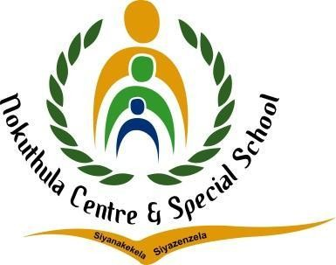
ENGLISH LESSON PLAN

TEL: (011) 444 6443
FAX: (011) 444 6955/2625944
E-MAIL: nokuthulasmh@mweb.co.za

Subject: English |  | Grade: 2 |  | Term: 3 |  |  | Week: 4-5
TOPIC: Road/Traffic Safety | Content:  - Listening and Speaking  - Phonological/Phonemic Awareness/Phonics  - Emergent Reading  - Shared Reading  - Handwriting and Writing |  | Time allocation:  2 hours daily |  |  | Date started: |  | Date completed:
Prior content knowledge:  - Learners should have prior knowledge about crossing the road.  - Learners use and see the road every day they come to school. |  | Lesson objectives: The learners must be able to:  - Identify Pedestrians  - Identify Cyclists  - Identify Passengers  - Identify basic Road signs like Stop, Pedestrian crossing, Robot - the colors and the meaning of it.  - Know how traffic officers help us |  |  | Vocabulary/ important words:  - Pedestrians  - Cyclists  - Passengers  - Road signs  - Robot  - road |  |  | Teaching strategies:  - Learner centered.  - Question and answer  - Demonstration


Resources:  - Chalkboard  - Classwork books  - Worksheets  - Pictures  - Poster  - Video  - Song | TEACHER’S ACTIVITIES  Listening and Speaking  - Introduce the lesson topic by playing rhyme video (Stop, look and listen, and before you cross the street).  - Ask learners how they cross the street when they are at home, going to the shops or to school.  - Teach the learners when you see a red Stop sign you must stop look around and wait until it is safe to proceed.  - Teach learners about the safety use of buses/taxis as transport when coming to school | LEARNER’S ACTIVITIES  - Learners watch the rhyme video.  - Learners actively participate in the class discussions and ask clarity seeking questions. | Assessment goal: Assessment strategy: Informal  X  Formal    Assessment tool:  - Rubric
 | Phonemic Awareness
 | - Recognize specific identified sight words from the lesson topic.  - Build and blend words with the taught word families.  - Recognize and name the letters of the alphabet. | - Learners actively listen to the ABC songs and try to identify letters of their own names.  - Learners attempt to answer given activities.
 | Reading  - Read a story on the importance of road safety. | - Learners read a story of road safety with the teacher. Predict what will happen next in the story using pictorial cues.

 | Handwriting and Writing  - Task learners to trace simple outlines of important road sign pictures.  - Give learners patterns (rounded, pointed, vertical lines), letters and words to trace. | - Learners trace simple outlines of important road signs and try to draw some of them.  - learners trace patterns, letter and words
Differentiation (Enrichment opportunities/ addressing barriers) |  |  | Practical task
- Group 1: Color in a stop sign.  - Group 2: Label the pictures.  - Group 3: Fill in the missing letters activity. |  |  | Learners will play a game of ‘Crossing the Road’. Learners will line up on the road and use what they have learned about the rules of the road, to cross the road.
Teacher reflection: |  |  | Name of Teacher:  TN BANDA
HOD Input: |  |  | Name of HOD:

